
Touchstones Project
Netcards

Ambiguity / Paradox Netcards with Text

Alternative Truth HRJ
Authoritarian HRJ
Bed HRJ
Boxes HRJ

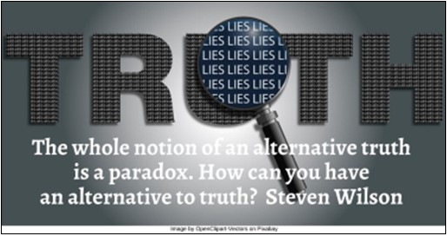

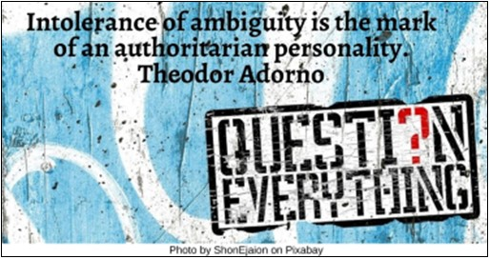

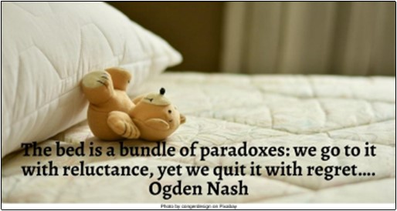

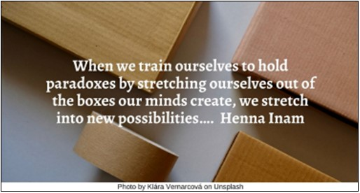

Buddha HRJ
Caterpillar HRJ
Child HRJ
Clock HRJ

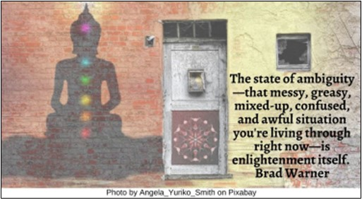

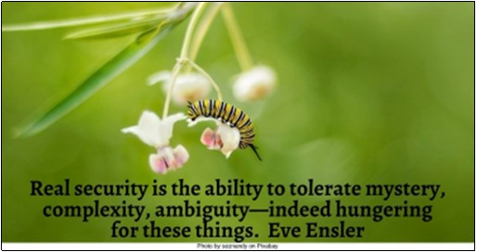

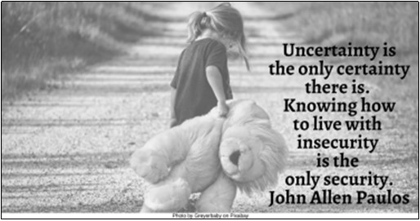

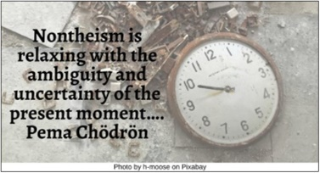

Dancing HRJ
Devastation HRJ
Eclipse HRJ
Faith HRJ

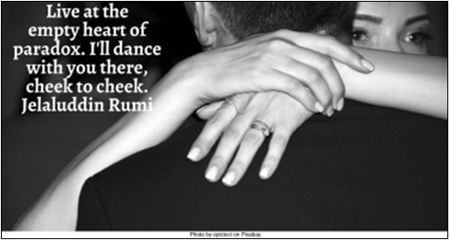

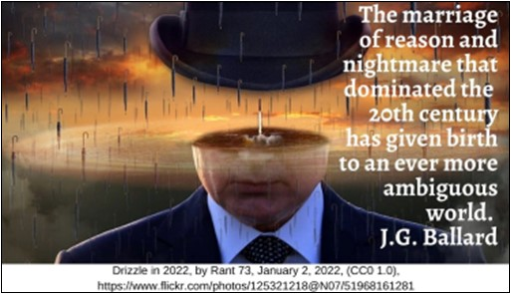

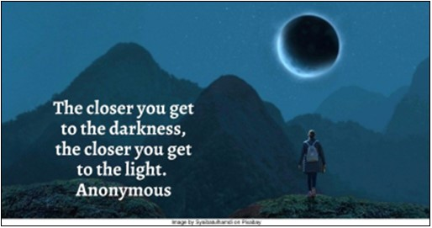

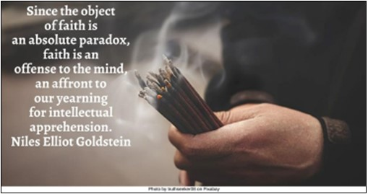

Forgiveness HRJ
Fundamentalist HRJ
Graveyard HRJ
Hearts HRJ

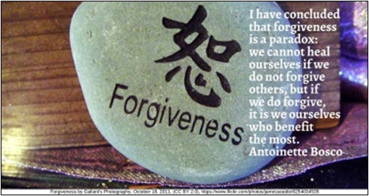

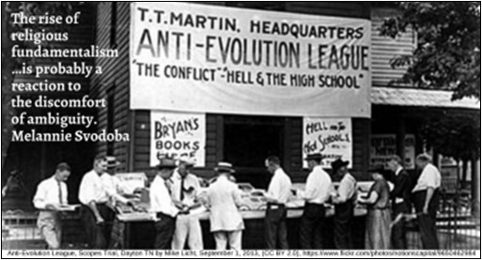

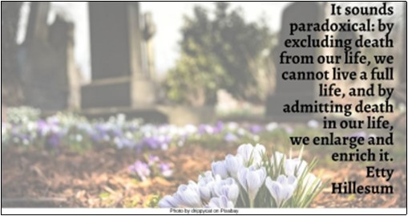

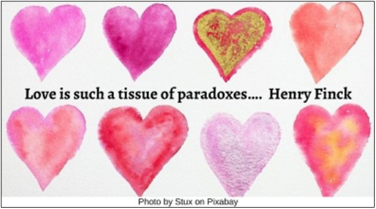

Highwire Act HRJ
Hospitality HRJ
Joy HRJ
Messy HRJ

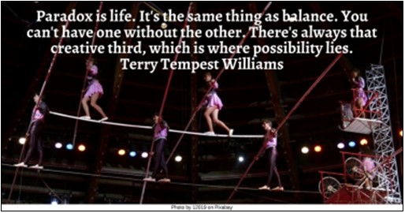

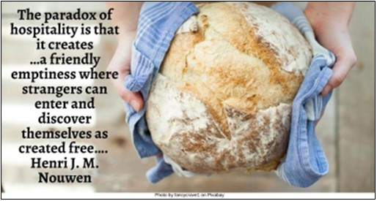



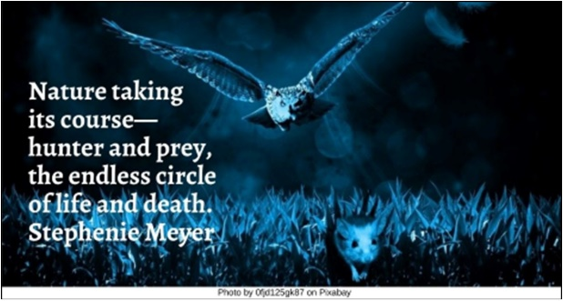

Mystery HRJ
Painter HRJ
Playing HRJ
Propaganda HRJ

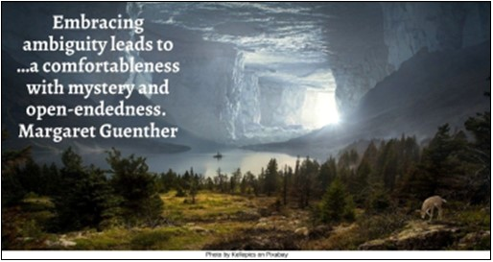

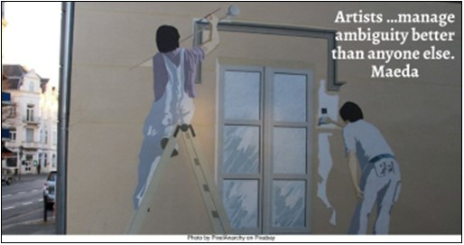

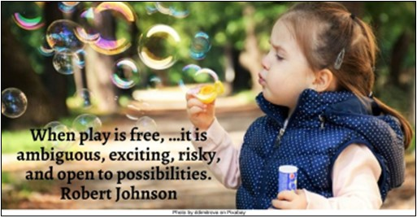

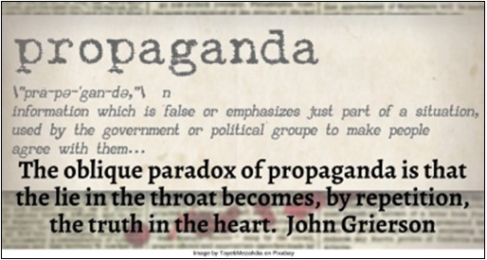

Scared HRJ
Stars HRJ
Talkative HRJ
Timeless HRJ

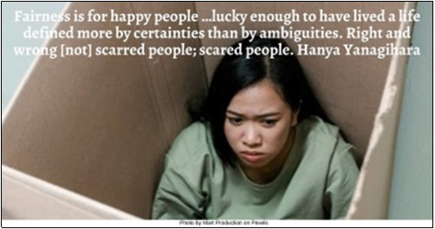

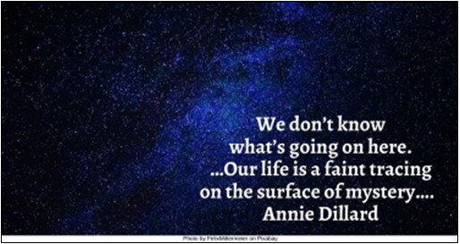

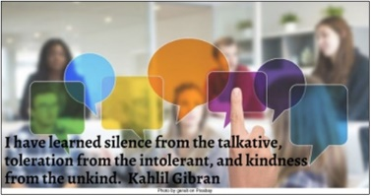

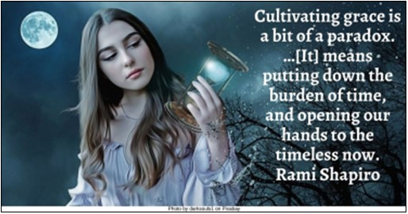

Truth HRJ
Wrestle HRJ
Yin Yang HRJ

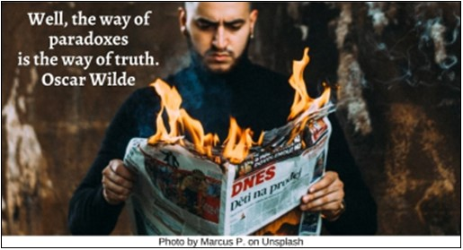

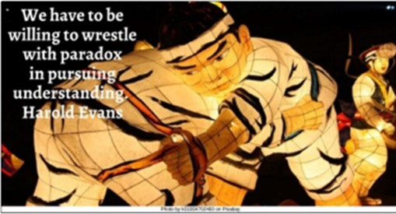

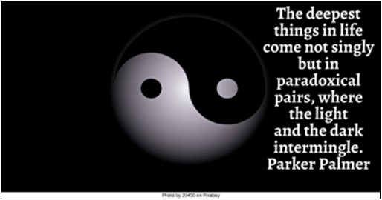

Text of Quotes
Alternative Truth HRJ
The whole notion of an alternative truth is a paradox. How can you have an alternative to truth? Steven Wilson

Authoritarian HRJ
Intolerance of ambiguity is the mark of an authoritarian personality. Theodor Adorno

Bed HRJ
The bed is a bundle of paradoxes: we go to it with reluctance, yet we quit it with regret…. Ogden Nash

Boxes HRJ
When we train ourselves to hold paradoxes by stretching ourselves out of the boxes our minds create, we stretch into new possibilities…. Henna Inam

Buddha HRJ
The state of ambiguity—that messy, greasy, mixed-up, confused, and awful situation you're living through right now—is enlightenment itself. Brad Warner

Caterpillar HRJ
Real security is the ability to tolerate mystery, complexity, ambiguity—indeed hungering for these things. Eve Ensler

Child HRJ
Uncertainty is the only certainty there is. Knowing how to live with insecurity is the only security. John Allen Paulos

Clock HRJ
Nontheism is relaxing with the ambiguity and uncertainty of the present moment…. Pema Chödrön

Dancing HRJ
Live at the empty heart of paradox. I'll dance with you there, cheek to cheek. Jelaluddin Rumi
Devastation HRJ
The marriage of reason and nightmare that dominated the 20th century has given birth to an ever more ambiguous world. J.G. Ballard

Eclipse HRJ
The closer you get to the darkness, the closer you get to the light. Anonymous

Faith HRJ
Since the object of faith is an absolute paradox, faith is an offense to the mind, an affront to our yearning for intellectual apprehension. Niles Elliot Goldstein

Forgiveness HRJ
I have concluded that forgiveness is a paradox: we cannot heal ourselves if we do not forgive others, but if we do forgive, it is we ourselves who benefit the most. Antoinette Bosco

Fundamentalism HRJ
The rise of religious fundamentalism …is probably a reaction to the discomfort of ambiguity. Melannie Svodoba

Graveyard HRJ
It sounds paradoxical: by excluding death from our life, we cannot live a full life, and by admitting death in our life, we enlarge and enrich it. Etty Hillesum

Hearts HRJ
Love is such a tissue of paradoxes…. Henry Finck
Photo by Stux on Pixabay

Highwire Act HRJ
Paradox is life. It's the same thing as balance. You can't have one without the other. There's always that creative third, which is where possibility lies. Terry Tempest Williams

Hospitality HRJ
The paradox of hospitality is that it creates …a friendly emptiness where strangers can enter and discover themselves as created free…. Henri J. M. Nouwen

Joy HRJ
That’s the great paradox of living on this earth, that in the midst of great pain you can have great joy as well. If we didn’t …we'd just be numb. Kathy Mattea

Messy HRJ
Though everything is a mess, all is well. Strange paradox, to be sure. Anthony de Mello

Mystery HRJ
Embracing ambiguity leads to …a comfortableness with mystery and open-endedness. Margaret Guenther

Painter HRJ
Artists …manage ambiguity better than anyone else. Maeda

Playing HRJ
When play is free, …it is ambiguous, exciting, risky, and open to possibilities. Robert Johnson

Propaganda HRJ
The oblique paradox of propaganda is that the lie in the throat becomes, by repetition, the truth in the heart. John Grierson

Scared HRJ
Fairness is for happy people …lucky enough to have lived a life defined more by certainties than by ambiguities. Right and wrong [not] scarred people; scared people. Hanya Yanagihara

Stars HRJ
We don’t know what’s going on here. …Our life is a faint tracing on the surface of mystery…. Annie Dillard

Talkative HRJ
I have learned silence from the talkative, toleration from the intolerant, and kindness from the unkind. Kahlil Gibran

Timeless HRJ
Cultivating grace is a bit of a paradox. …[It] means putting down the burden of time, and opening our hands to the timeless now. Rami Shapiro

Truth HRJ
Well, the way of paradoxes is the way of truth. Oscar Wilde

Wrestle HRJ
We have to be willing to wrestle with paradox in pursuing understanding. Harold Evans

Yin Yang HRJ
The deepest things in life come not singly but in paradoxical pairs, where the light and the dark intermingle. Parker Palmer

